**How to check the automation exercises:**

1º Download Jmeter v4.0. and install in your pc. <https://jmeter.apache.org/download_jmeter.cgi>

2º Download postman and install in your pc. <https://www.getpostman.com/>

3º Go to <https://github.com/pablodiazcruz/ITRS> and download the files Countries.txt, RestCountries.postman_collection.json and Beanshell_ITRS.jmx.

4º Open Postman and import the file RestCountries.postman_collection.json. Go to Collection tabs and you will have the RestCountries collections:

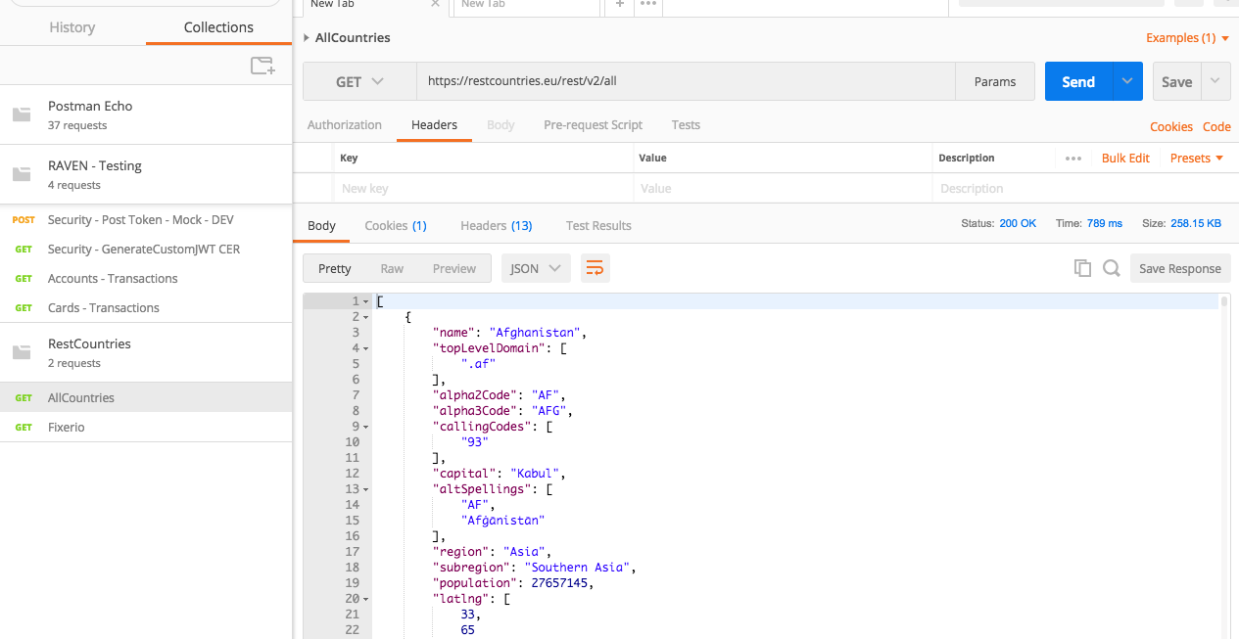

Here you have the list with all countries, capital, currency…etc. The file countries.txt have all that information.

*I do not have the information regarding with appartmentName, apartmentPrice…etc, where do I need to get that information?. I can create a python script which will generate that information if you wish.

5º. Beanshell script. Open jmeter and open the script beanshell_ITRS.jmx

6º Go to User Defined variables and change the path for a path in your system.

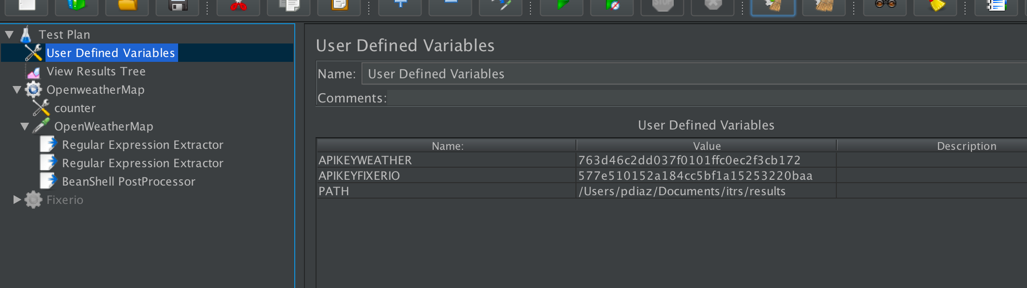

7º Run the script clicking on play and you will see the results in the View results tree.

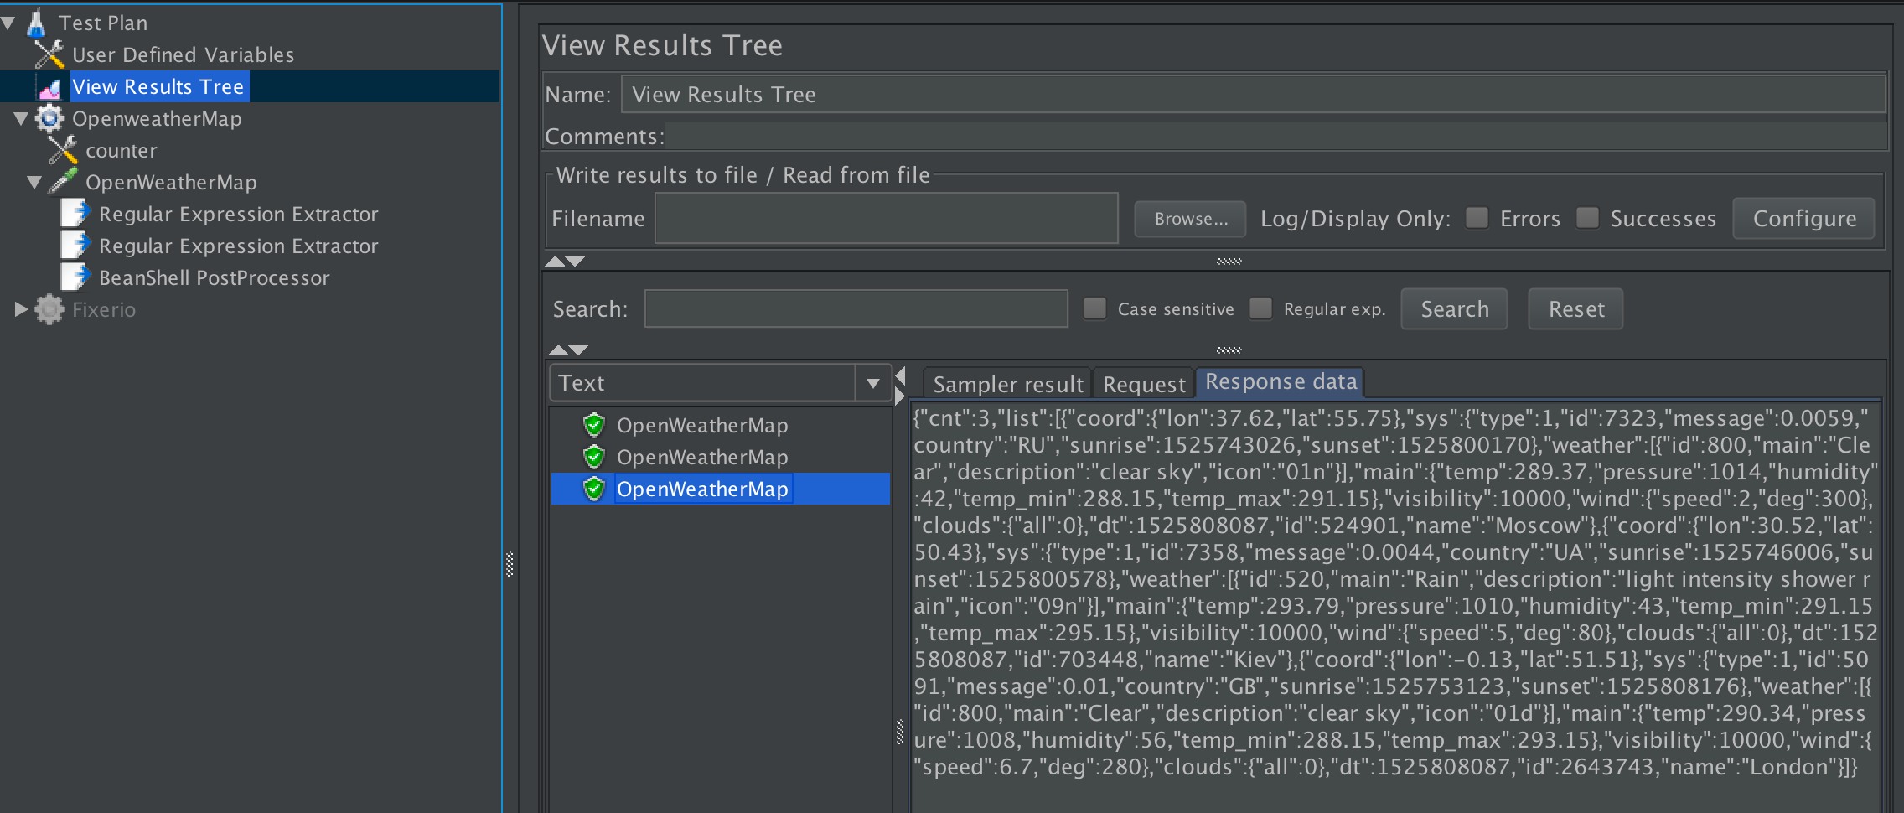

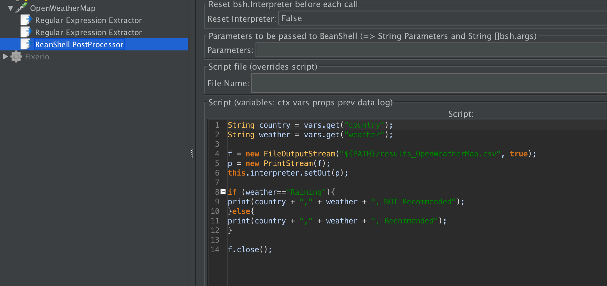

8º Finally, go to the path selected and you will have the file with the data of 3 countries. 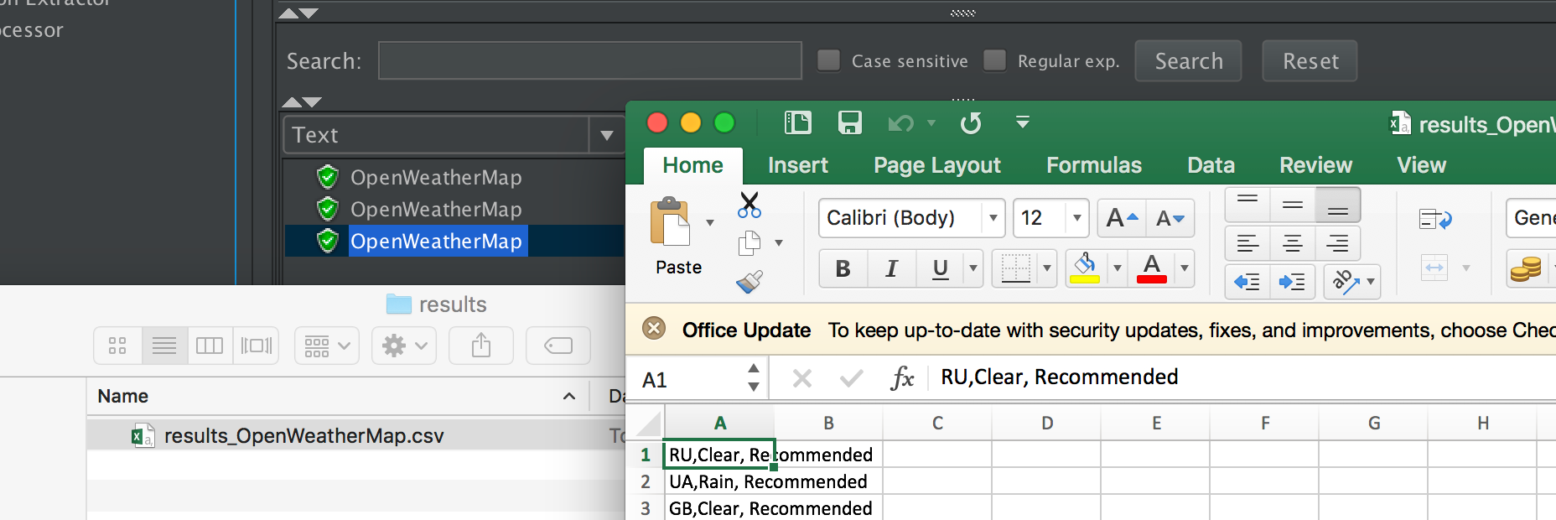

If you want to add more countries, you can modify the number in the request below:

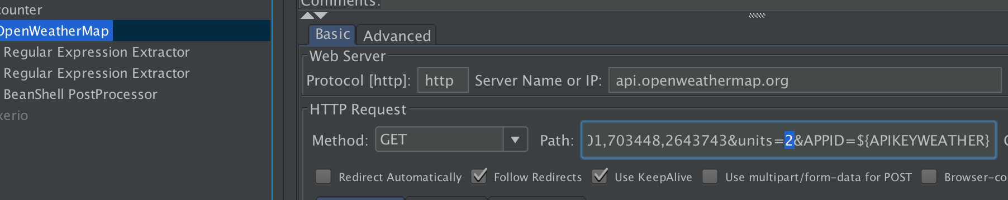

9º You will find the api “fixer.io” in postman collection or in Jmeter script, but I didn´t find anything regarding with apartment, apartment price…etc. Anyway, if I am not wrong, this exercise is quite similar to previous one.

10º Download from <https://github.com/pablodiazcruz/ITRS> the file [Theory Questions.docx](https://github.com/pablodiazcruz/ITRS/blob/master/Theory%20Questions.docx) and you will find the answers to the theory questions.